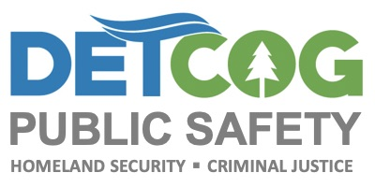
2020 Back to School Traffic Safety Tip

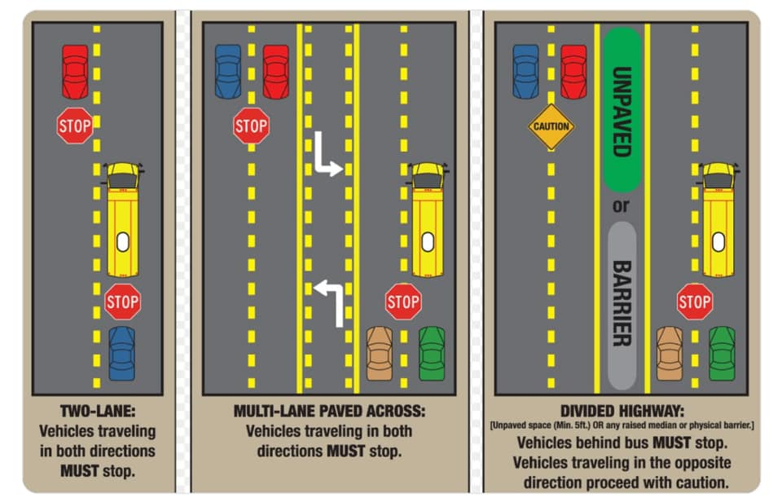

Please remember that our children are back in school and to obey Traffic Laws. Slow Down, Stay off Cell Phones and Pay Attention to School Busses Loading & Unloading!!!

